Admission Application for the University of Aizu
Graduate School Research Student for Academic Year 2019
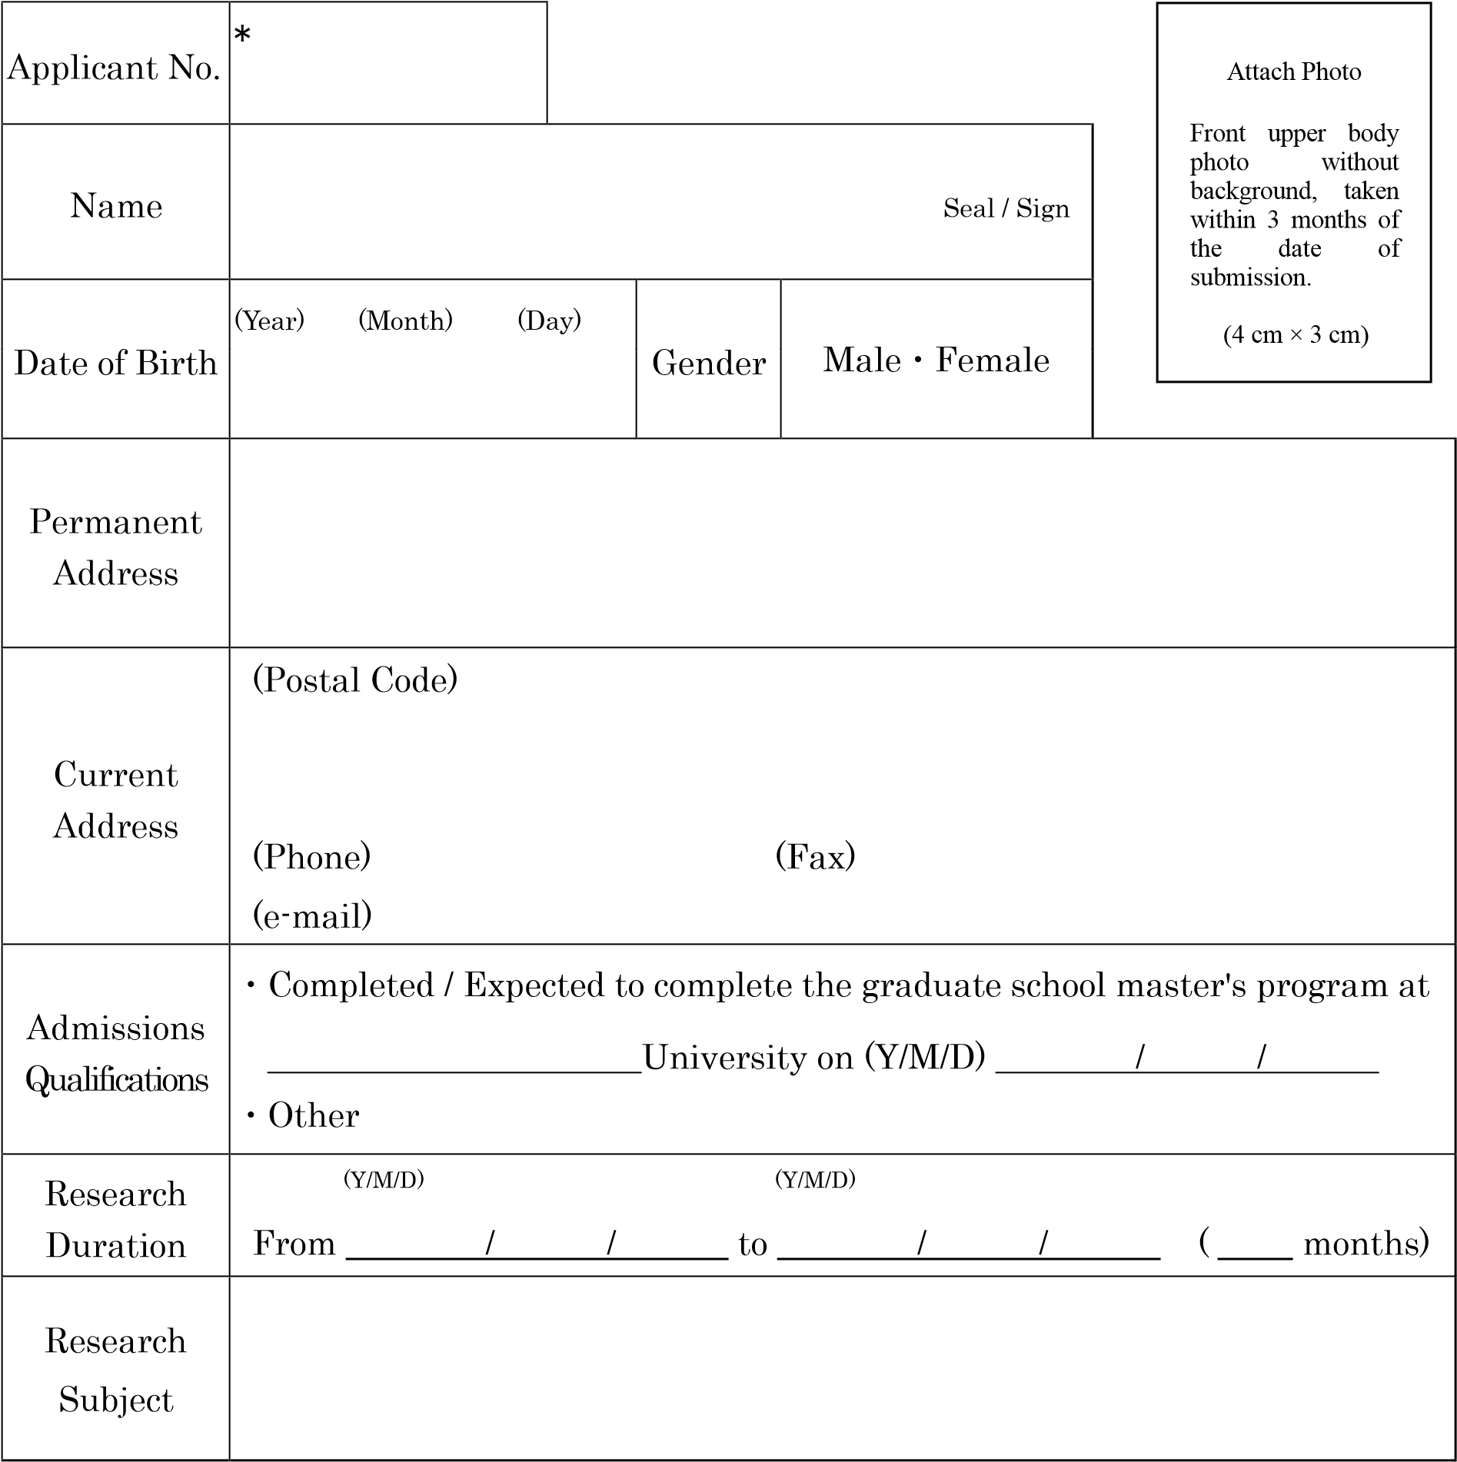
Notes
- Do not fill in the column marked with a “＊”.
- Attach a proof of payment of the application fee to the back of this form.
I consent to serve as the Research Advisor for the above-mentioned individual if the individual is admitted to the Graduate School as a research student.
Date (Y/M/D) / /
Faculty member to be assigned Seal / Sign

<Proof of payment>

(Paste the document certifying payment of application fee here.)

