Admission Application for the University of Aizu Graduate School Non-Degree Student for Academic Year 2019

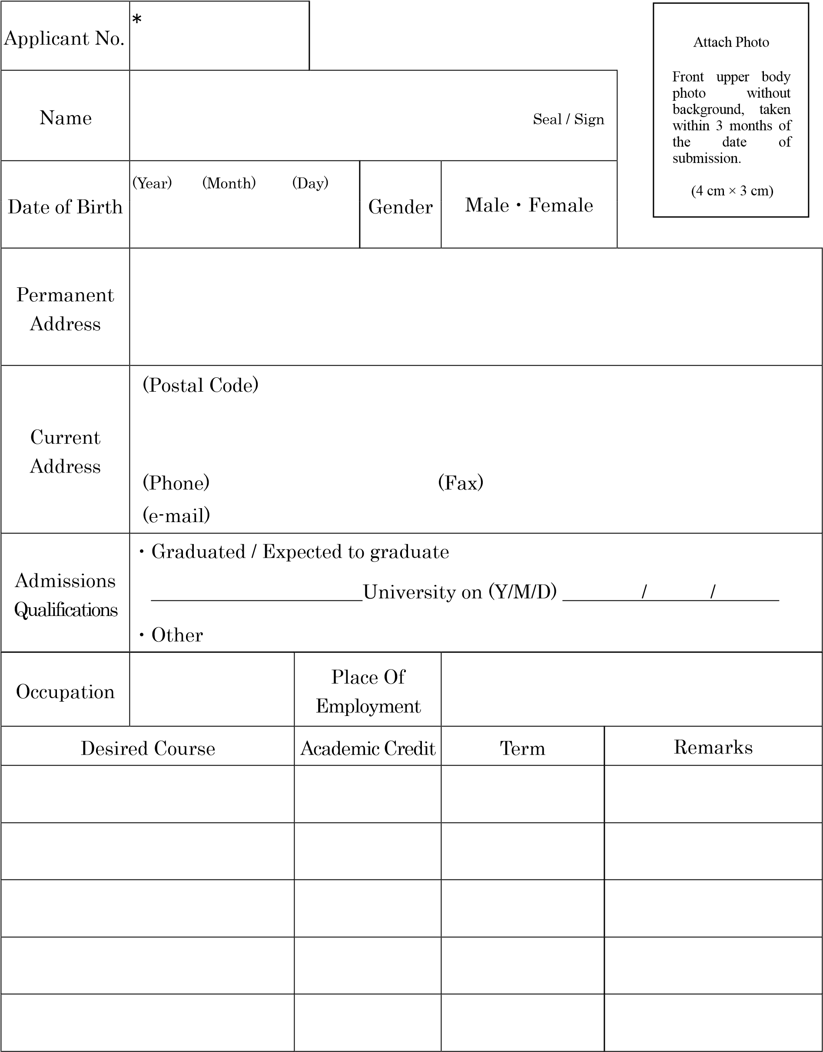
Notes
- Do not fill in the column marked with a “＊”.
- Attach a proof of payment of the application fee to the back of this form.
<Proof of payment>

(Paste the document certifying payment of application fee here.)

