Algorithms and Data Structures
Algorithm Assignment: Lecture 12

ID: Name:
1. Illustrate Prim’s Algorithm to find the minimum-spanning-tree (MST) of the following graph. Show edges added to MST in order.
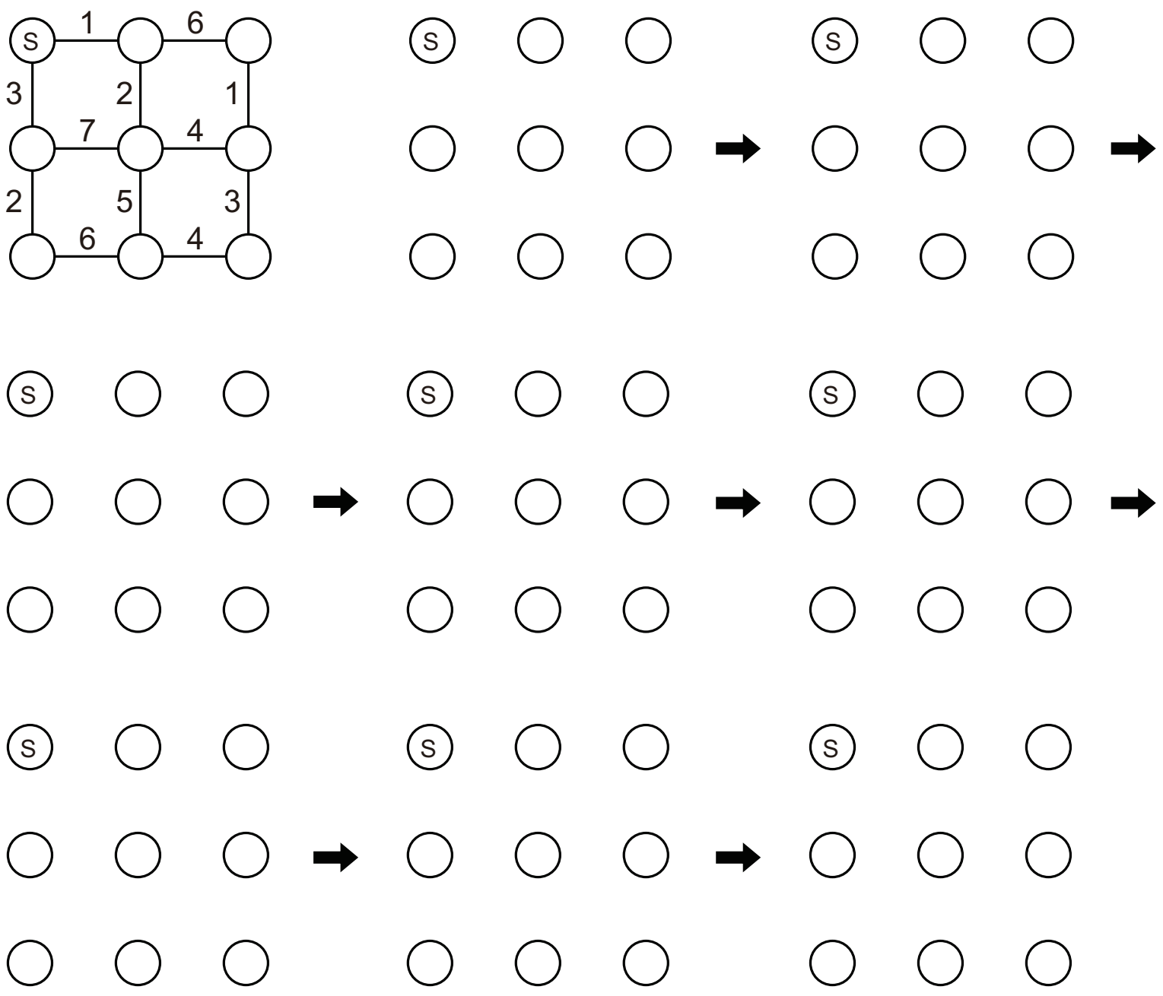
2. Find the number of ways to go to node ’G’ from node ’S’.
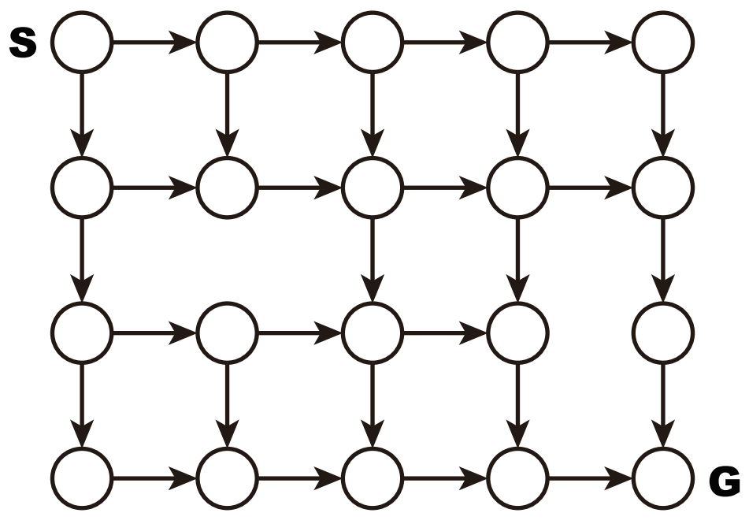
3. Illustrate the shortest path from node ’S’ to node ’G’ for the following graph.
