Algorithms and Data Structures
Algorithm Assignment: Lecture 11

ID: Name:
1. Give an adjacency-matrix representation of a graph G = (V, E) shown in Fig. 1.
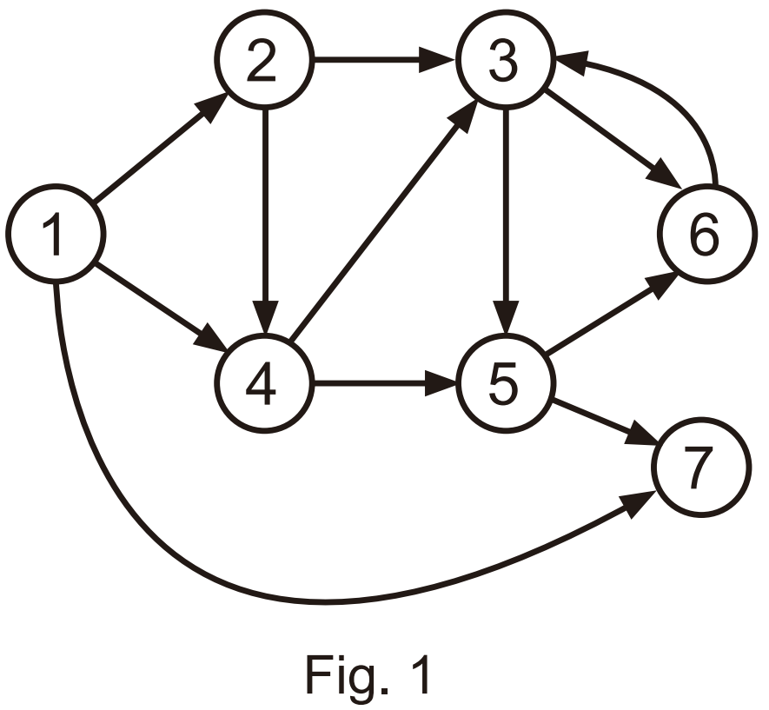
2. Show how DFS works on the graph of Fig. 1. Assume that elements in each adjacency list are ordered numerically. Show the discovery and finishing times for each vertex.
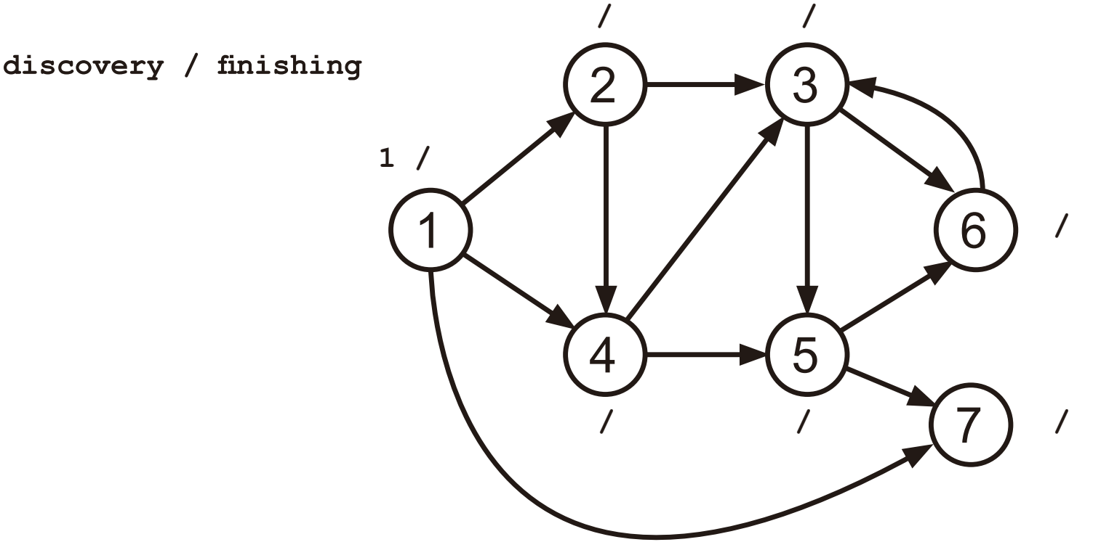
3. Show how BFS works on the graph of Fig. 1 by presenting distance d[v] from s (= 1) for each vertex.
