Algorithms and Data Structures
Algorithm Assignment: Lecture 10

ID: Name:
1. Find an optimal parenthesization of a matrix-chain product whose sequence of dimensions is {5, 10, 3, 12, 5}. Illustrate your algorithm.
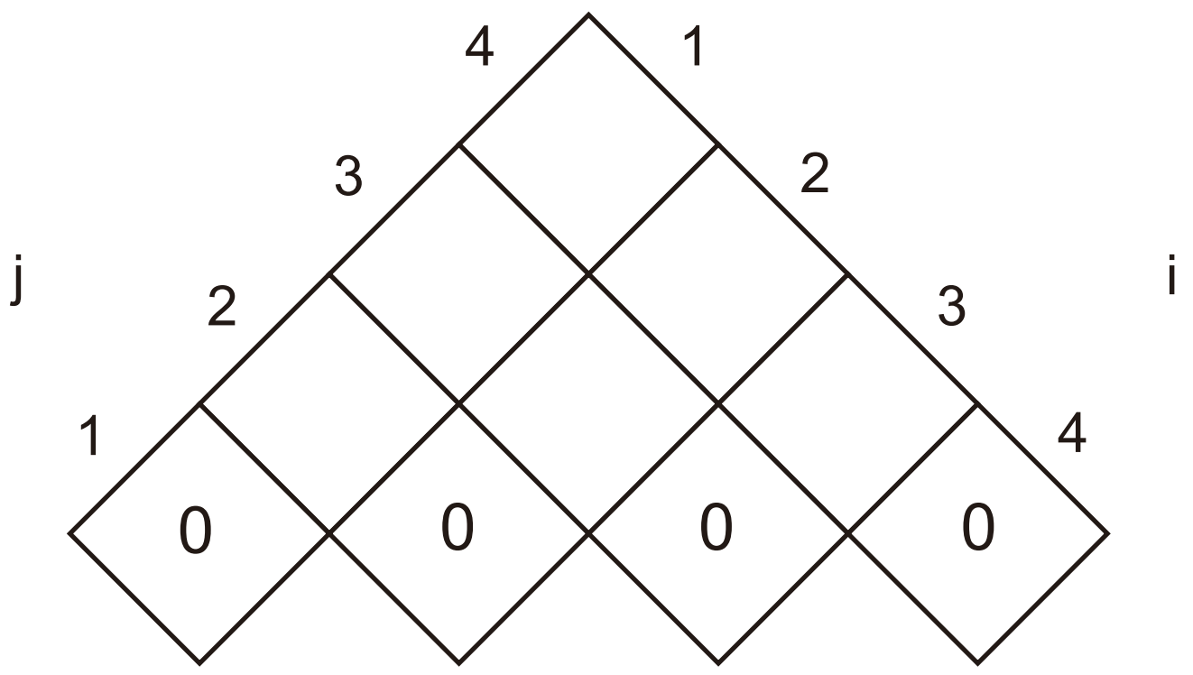

2. Determine an LCS of {1, 0, 0, 1, 0, 1, 0, 1} and {0, 1, 0, 1, 1, 0, 1, 1, 0}. Illustrate your algorithm.
