Algorithms and Data Structures
Algorithm Assignment: Lecture 9

ID: Name:
1. Illustrate a max-heap constructed by a buildMaxHeap operation with an array A = {5, 3, 17, 10, 84, 19, 6, 22, 9}. You should follow the pseudocode in the lecture note.
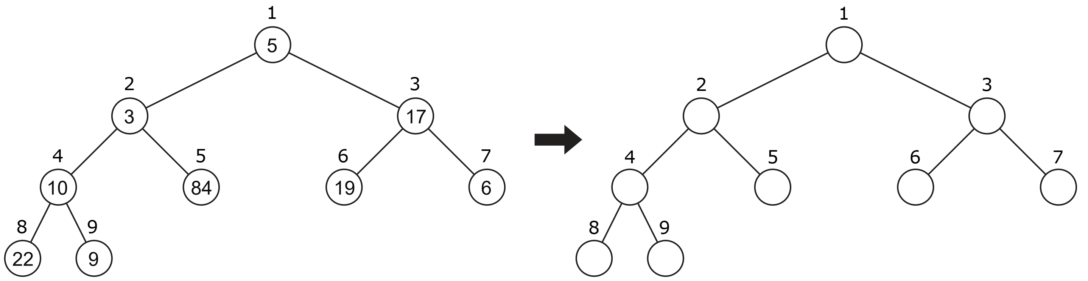

2. Illustrate a max-heap constructed by a heapExtractMax operation to a heap A = {15, 13, 9, 5, 12, 8, 7, 4, 0, 6, 2, 1}. You should follow the pseudocode in the lecture note.
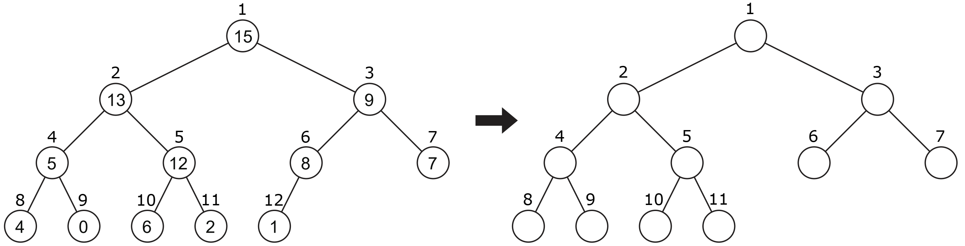

3. Illustrate a max-heap constructed by a maxHeapInsert(A, 10) operation to a heap A = {15, 13, 9, 5, 12, 8, 7, 4, 0, 6, 2, 1}. You should follow the pseudocode in the lecture note.
