Algorithms and Data Structures
Algorithm Assignment: Lecture 8

ID: Name:
1. Construct a binary search tree obtained by inserting keys {12, 6, 20, 8, 15, 80, 17, 10} in this order. You should follow the pseudocode in the lecture note.

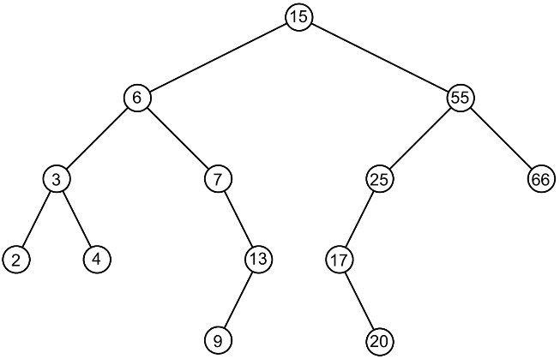
2. Answer the following questions related to a binary search tree T illustrated in the following Figure. The number k represents the key of the node (Hereinafter, called “node k”).
(a) What is the key of the successor of node 7?

(b) What is the key of the successor of node 13?

(c) What is the key of the successor of node 15?

3. Answer the following questions related to a binary search tree T illustrated in the above Figure. You should follow the pseudocode in the lecture note.
(a) Draw a binary search  tree after deleting node  7 from T. | (b) Draw a binary search  tree after deleting node  6 from T. | (c) Draw a binary search  tree after deleting node  15 from T.

