Algorithms and Data Structures
Algorithm Assignment: Lecture 7

ID: Name:
1. Answer the following questions related to a rooted tree T illustrated in the figure.
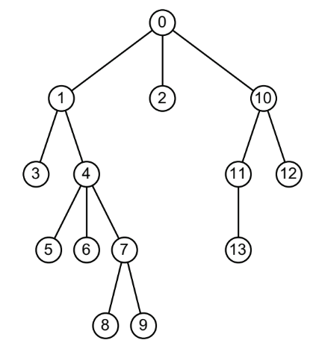
(a) Which is the root node of T?

(b) List internal nodes of T.

(c) List external nodes (leaf) of T.

(d) Which is the parent of node 7?

(e) What is the degree of node 4?

(f) What is the depth of node 6?

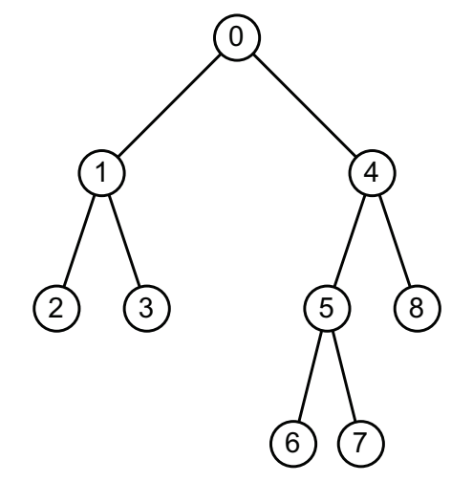
2. Answer the following questions related to a binary tree T illustrated in the figure.
(a) Which is the sibling of node 5?

(b) What is the degree of node 5?

(c) What is the height of node 4?

(d) What is the height of node 1?

(e) What is the height of tree T?

3. Write a sequence of nodes obtained by preorder tree walk, inorder tree walk and postorder tree walk on a binary tree T illustrated in the following figure.
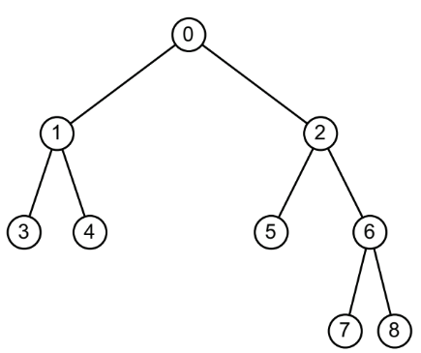
(a) Preorder tree walk

(b) Inorder tree walk

(c) Postorder tree walk

