Algorithms and Data Structures
Algorithm Assignment: Lecture 6

ID: Name:
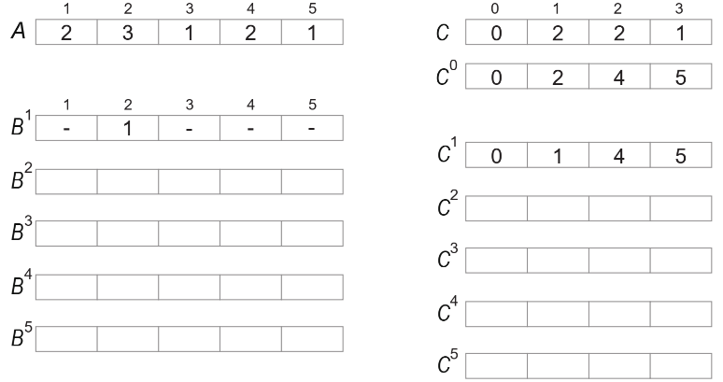
1. Using the algorithm, Counting Sort, sort a sequence A = {2, 3, 1, 2, 1} in ascending order. You should illustrate how the algorithm works on the sequence by showing intermediate results of B^{k} and C^{k}. (please see the lecture note for the details of these arrays).

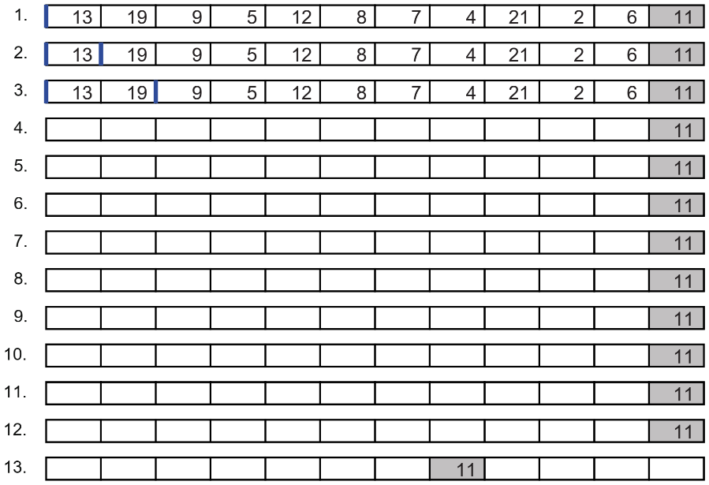
2. Illustrate a procedure of the Partition for a sequence A = {13, 19, 9, 5, 12, 8, 7, 4, 21, 2, 6, 11}. You should follow the pseudocode presented in the lecture note.

3. Illustrate a procedure of the Quick Sort algorithm for a sequence A which is obtained by the step 13 of the previous question. You should use the pseudocode defined in the lecture note.
