Algorithms and Data Structures
Algorithm Assignment: Lecture 5

ID: Name:
1. Write a pseudocode of a recursive function which computes n! (factorial of n).

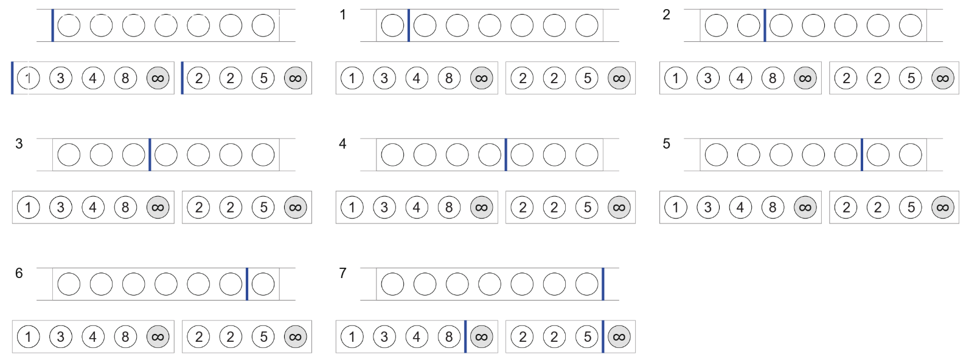
2. Merge two ordered sequences A = {1, 3, 4, 8} and B = {2, 2, 5} into an ordered sequence. You should use sentinels in your algorithm. Indicate indices (vertical bars) of A and B.

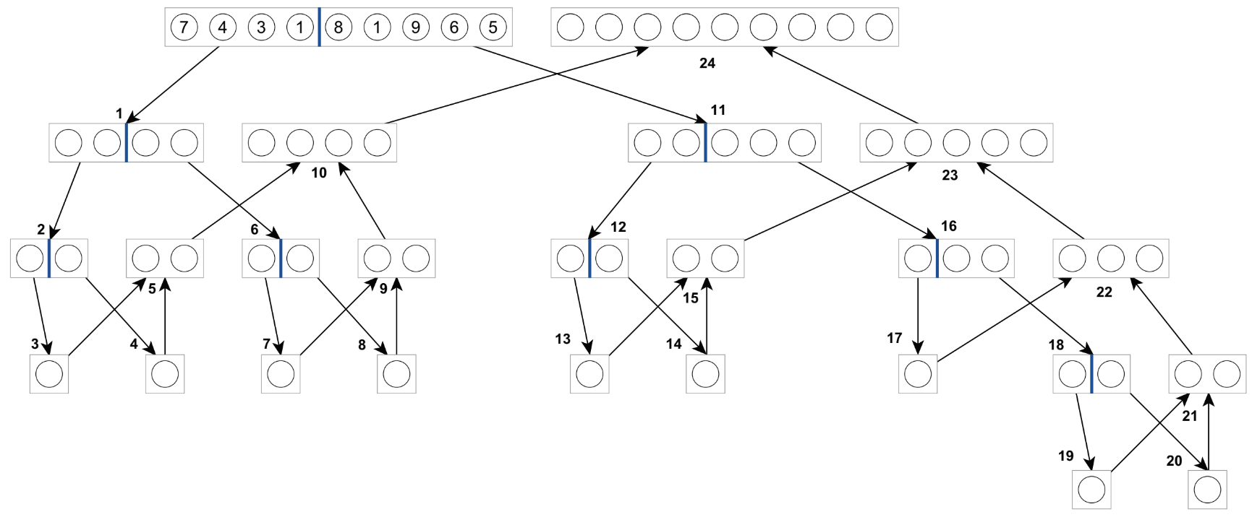
3. Illustrate a procedure of the Merge Sort algorithm based on lecture note for sorting a sequence A = {7, 4, 3, 1, 8, 1, 9, 6, 5} in ascending order. Fill the elements from 1 to 24 in order to follow the Divide and Conquer algorithm.

