Algorithms and Data Structures
Algorithm Assignment: Lecture 3

ID: Name:
1. Illustrate the result of operations push(S, 4), push(S,1), push(S, 3), pop(S), push(S, 8), and pop(S) on an initially empty stack S implemented by an array. Each operation should be performed in O(1).
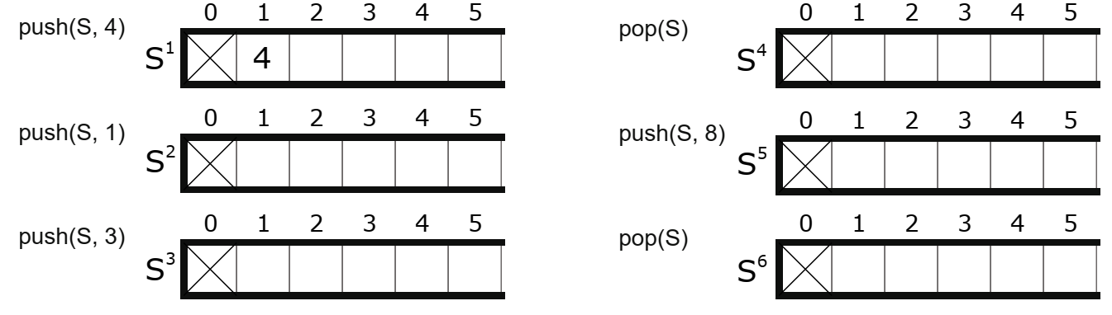
2. Illustrate the result of operations enqueue(Q, 4), enqueue(Q, 1), enqueue(Q, 3), dequeue(Q), enqueue(Q, 8), and dequeue(Q) on an initially empty queue Q implemented by an array. Each operation should be performed in O(1).
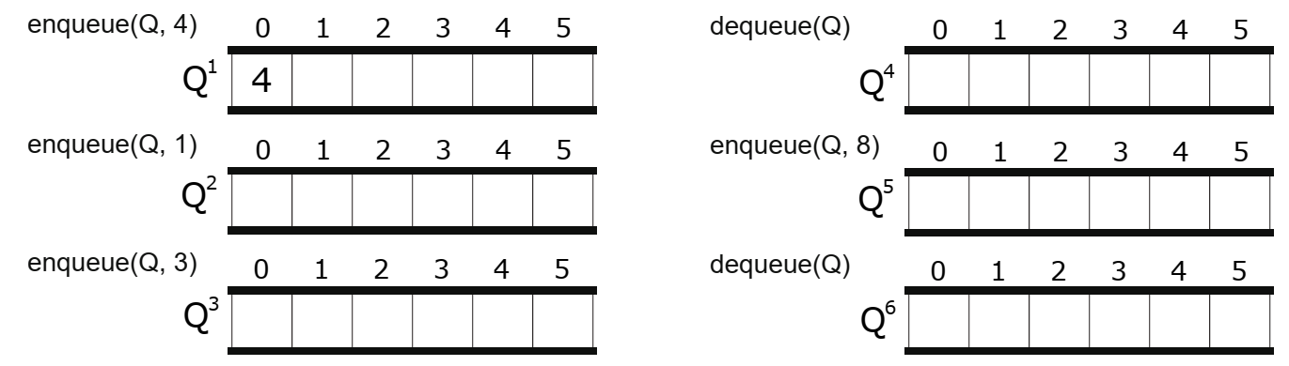
3. The following figures show operations of insert(L, x) and insert(L, y) on an initially empty doubly linked list L. Write pseudo codes for operations from (1) to (8).
