Algorithms and Data Structures
Algorithm Assignment: Lecture 2

ID: Name:
1. Using the algorithm, Selection Sort, sort the following sequence: A = {9, 6, 2, 8, 1, 4} in ascending order. Let swap(a, b) be an operation to swap A_{a} and A_{b}.
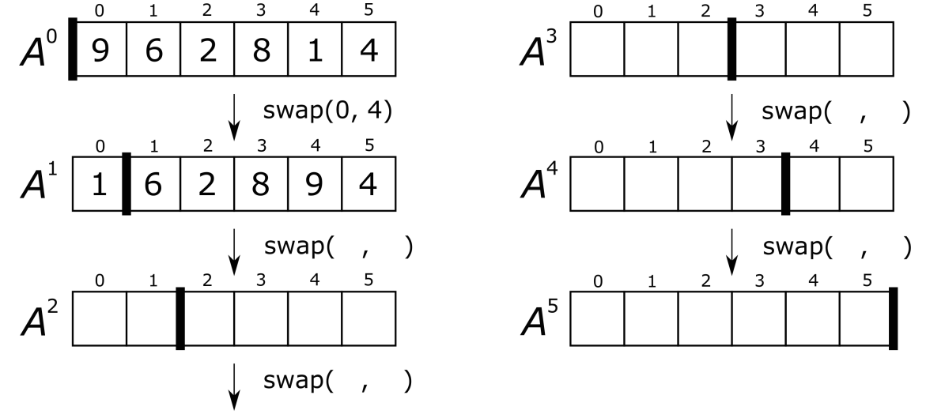
2. Using the algorithm, Bubble Sort, sort the following sequence: A = {3, 1, 2, 6, 9} in descending order. You should illustrate how the algorithm works on the sequence. Let swap(a, b) be an operation to swap A_{a} and A_{b}.
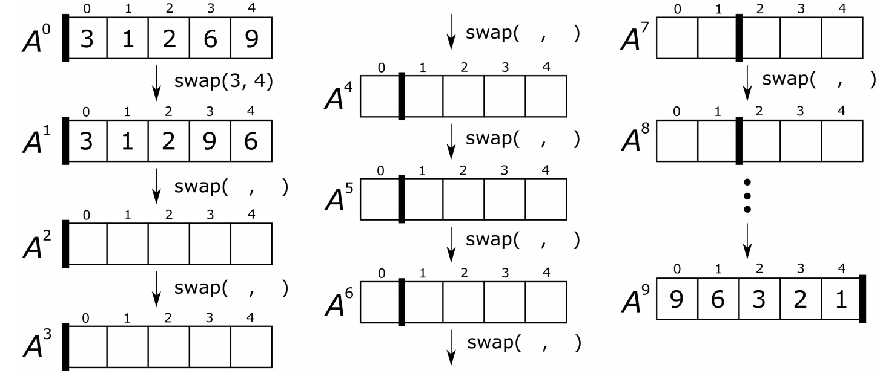
3. Arrange the following classes of functions in ascending order of growth rate.

O(n), O(1), O(n!), O(n²), O(n¹⁰), O(2^{n}), O(n log n), O(log n)
O( ) O( ) O( ) O( ) O( ) O( ) O( ) O( )

