Algorithms and Data Structures
Algorithm Assignment: Lecture 1

ID: Name:
1. Using the algorithm, Insertion Sort, sort the following sequence: A= {28,12,68,21,53,39} in ascending order. Let insert (p, x) be an operation to insert x to A_{p}.
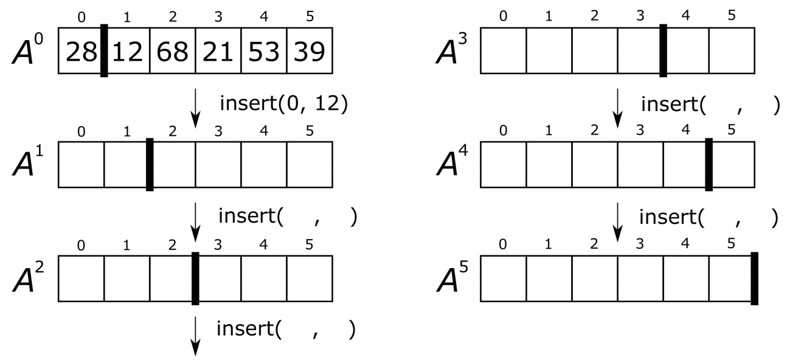
2. Write a pseudocode of the Insertion Sort algorithm which sorts a sequence B with N elements in descending order.

